

**American International University- Bangladesh  
Faculty of CSE**

**Advance Database Management System**

Section: B (Fall 2022-2023)

Teacher: JUENA AHMED NOSHIN

Project Name:Superstore Management System

**Group Members NAME, ID and Contribution:**

|  |  |  |
| --- | --- | --- |
| Name | Id | Contribution |
| Md. Didarul Alam Alif | 20-44289-3 | ER Diagram, Normalization, Table Creation, Data Insertion, Schema Diagram ,Query Writing |
| Shaown Barua | 19-40674-1 | Introduction, Project Proposal , Scenario Description , Conclusion |
| Rakirul Haque | 19-39406-1 | ER Diagram,interfaces, Table Creation, Data Insertion |
| Shahriar, B.M. Mahir | 19-40538-1 | Cover Page, Class Diagram, Use Case Diagram, Activity Diagram |

Table of Contents

Introduction 3

Project Proposal 4

Class Diagram 5

Use case diagram 6

Activity Diagram 7

Interface 8

Scenario Description 12

ER Diagram 13

Normalization 14

Schema Diagram: 21

Table Creation: 22

Data Insertion: 29

Query Writing: 35

**Conclusion:** 41

# Introduction

The purpose of database design for Super Store Management System is to assist in the buying of products, billing, and making purchase transactions quick and accurate. This management system supports in the storage and security of sales data. It allows employees and company owners to effortlessly monitor and modify business transactions. It could save time by eliminating the need to write down all of the pertinent facts and data about the business transaction and the customer. This system processes and saves all of the store's data and information. All information on customers, employees, items, sales, importers, and transactions will be stored in the system's database. This management system enables the owner to keep track of the items or sales that the consumer purchases. The user or authorized individual can only log in as a staff administrator on the Cashier system.

# Project Proposal

A super store is a large store that stocks many varieties of good in different departments. This is a retail offering a large number of consumer goods belonging to different product catagories. As we know a superstore deal with lots of importers, customers and stuffs. This superstore management system has realized the transmission and control of large goods, so as to facilitate the management and decision of sales, and reduce a big burden for superstore and superstore managers. It also can help to improve the work efficiency of superstore. Its requirements is to provide the basic information maintenance function of employees, customers and products so that managers can through the function to add, delete, and modify the basic information of employees and the employees can through it to add, modify and delete the basic information of customers and goods. A super store allowing the customers to buy his requirements under one roof. This project 'super store management system ' which is designed to handles all the transaction done in the shop. This system is developed to computerize the store works. When a bundle of products are purchased from the importers, all the details are noted down along with the importers name, id,phone no and email. The quantity purchased is entered in the stock. Initially the name of the product is saved in the database.as like customers are buying their requirement products and all the details are noted along with customers name,id,address, phone no, email and also noted down the payment transection .

Class Diagram

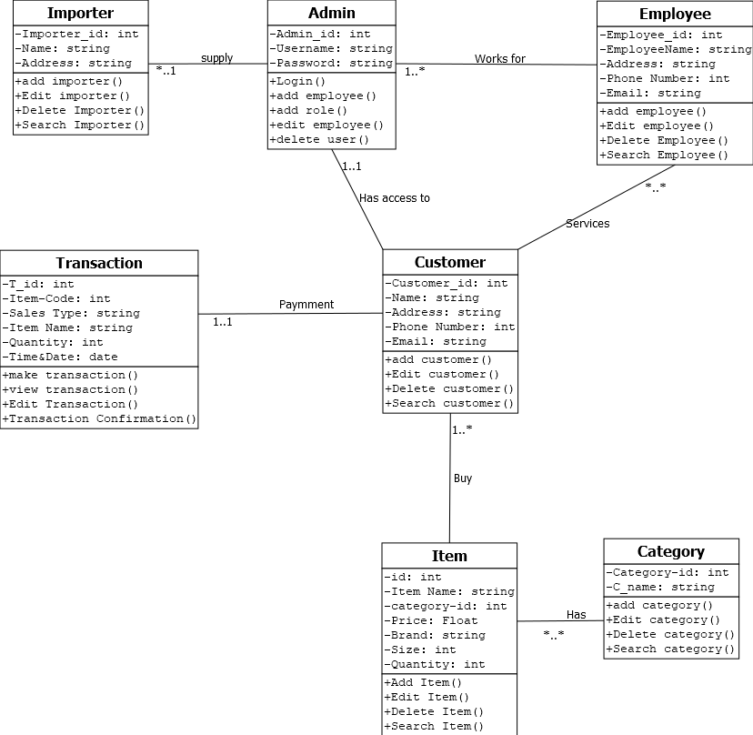

# Use case diagram

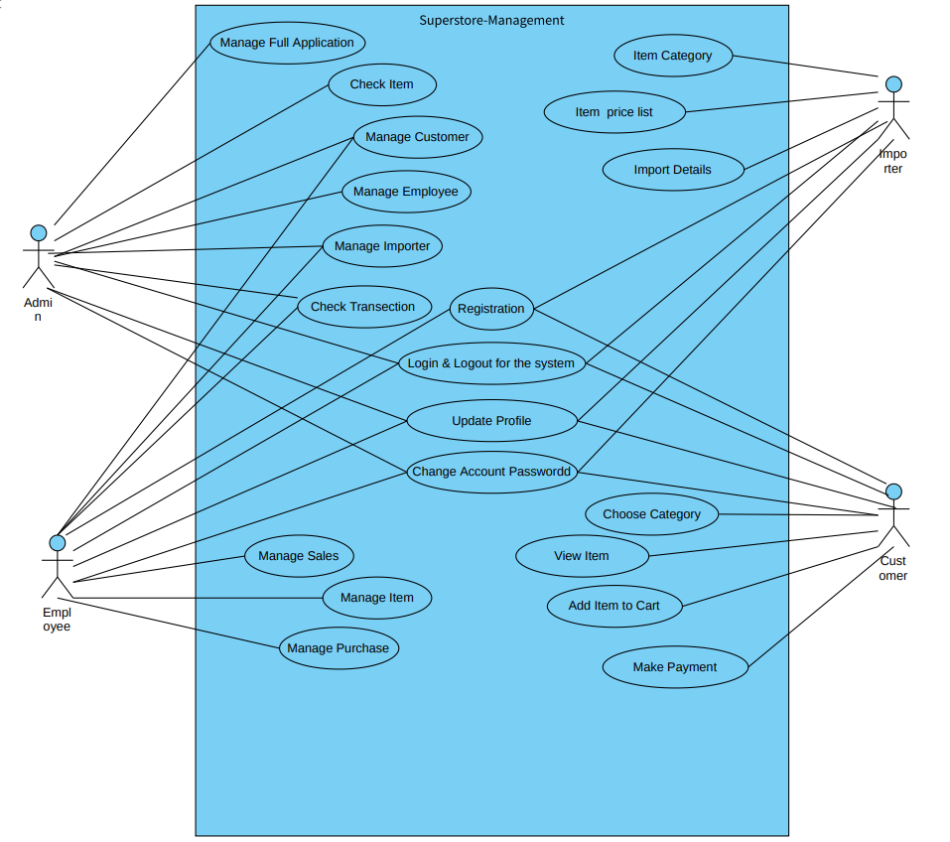

# Activity Diagram

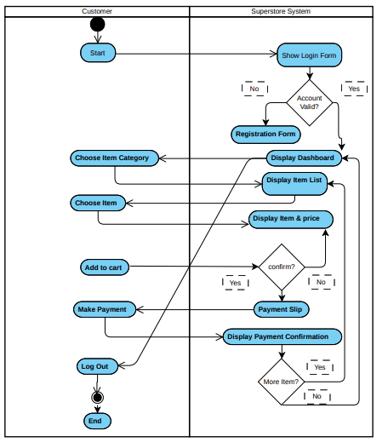

# Interface

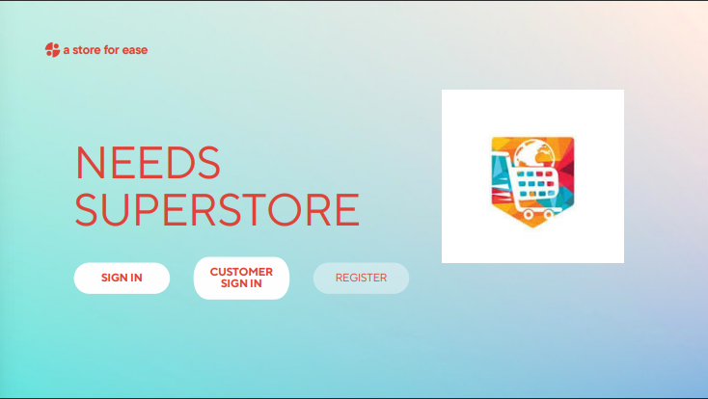

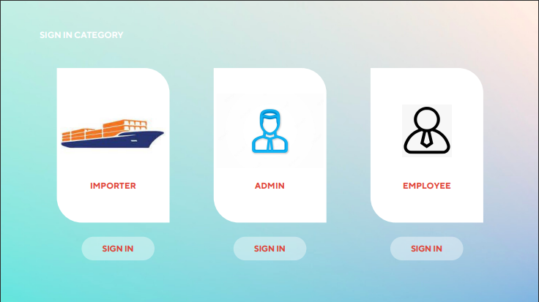

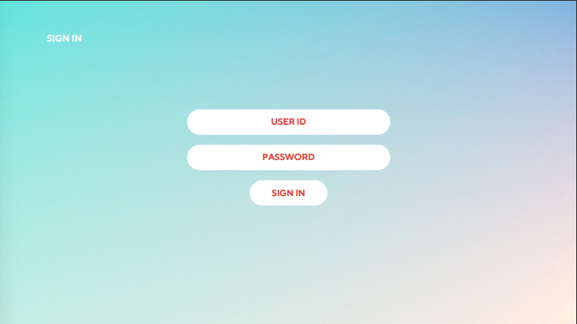

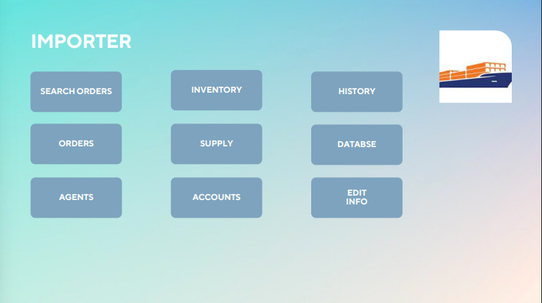

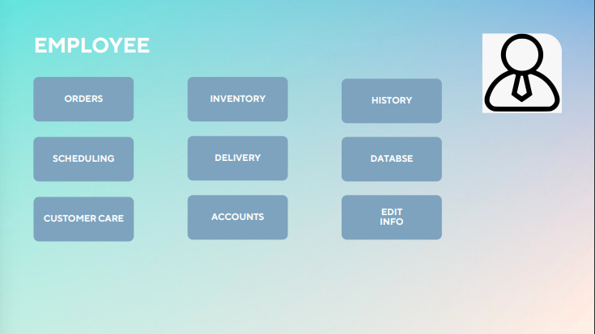

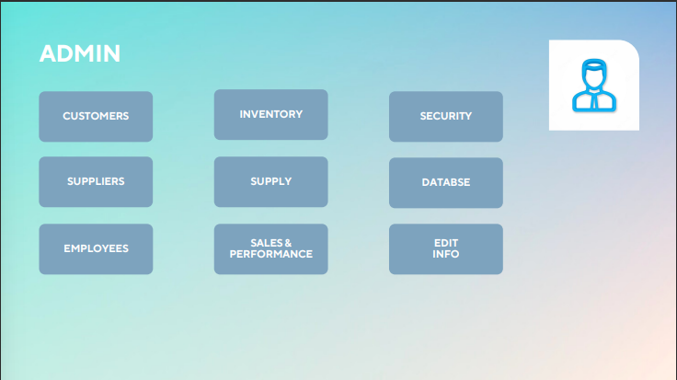

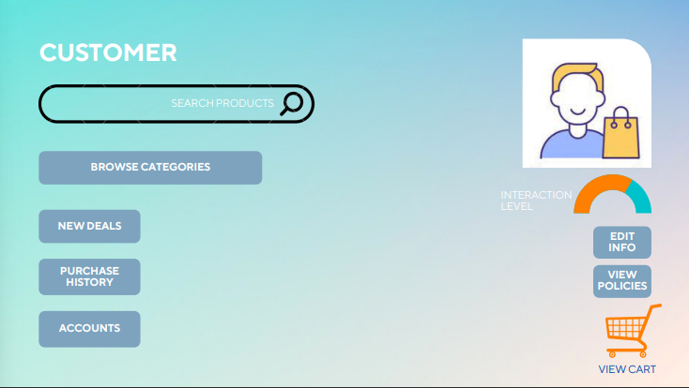

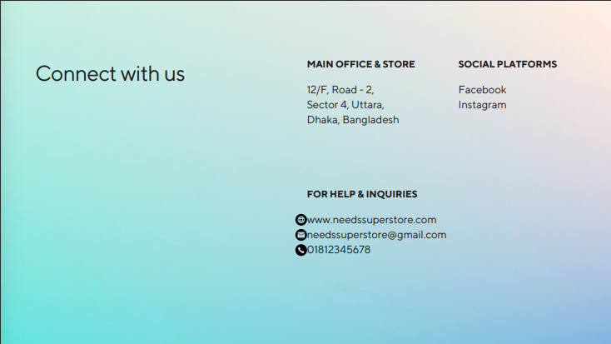

# Scenario Description

In a superstore management, a store is conducted by its admin that including(admin id, name and password). A store has many importers. They supply products for the store and they are identified by importer id, i_name,i_address,i_phone number and i_ email. A store can get products from many importers and one importer maybe supply to exactly one store. A store has multiple employees. But an employee could be work on exactly one store. An employee is identified by employee name, employee id, e_ address, e_ phone number and e_email. A store has many customers. One customer can visit one store at a time. Customer is identified by c_ name,customer_ id,c_ phone number, c_email and c_address. A customer can get service from many employees and an employee can give service to many customers.  An item is identified by  id,item name, category_id, price, brand, size and quantity. An item has many category and a category is associated with several item .A category can be identified by category name,category-id.A customer has to pay bills for the products. The transaction is identified by t_id, item_code, item_ name, quantity, sales type, time & date. A customer can make a transaction at a time and a transaction can be for one customer.

# Diagram Description automatically generatedER Diagram

Normalization**(Normalize up to 3rd Normal Form):**

**Supply**

**UNF :**

Supply ( Admin_id , User Name, Password, Importer_id, i_Name, i_Address,i_Phone Number,i_Email)

**1NF:**

Phone Number is a multivalued attribute

1 . Admin_id , User Name, Password, Importer_id, i_Name, i_Address,i_Phone Number,i_Email

**2 NF :**

1. Admin_id , User Name, Password

2. Importer_id, Name, Address,Phone Number,Email

**3 NF:**

There is no transitive dependency . Relation already in 3NF.

1 . Admin_id , User Name, Password

2. Importer_id, i_Name, i_Address,i_Phone Number,i_Email

**Table creation :**

1 . Admin_id , User Name, Password

2. Importer_id, i_Name, i_Address,i_Phone Number,i_Email, **Admin_id**

**Works For**

**UNF :**

Works For ( Admin_id , User Name, Password,Employee_id,Employee Name, e_Address,e_Phone Number,e_Email)

**1NF:**

Phone Number is a multivalued attribute

1 . Admin_id , User Name, Password,Employee_id, Employee Name, e_Address,e_Phone Number,e_Email

**2 NF :**

1. Admin_id , User Name, Password

2. Employee_id, Employee Name, e_Address,e_Phone Number,e_Email

**3 NF:**

There is no transitive dependency . Relation already in 3NF.

1 . Admin_id , User Name, Password

2. Employee_id, Employee Name, e_Address,e_Phone Number,e_Email

**Table creation :**

1 . Admin_id , User Name, Password

2. Employee_id, Employee Name, e_Address,e_Phone Number,e_Email, **Admin_id**

**Services**

**UNF :**

Services ( Employee_id,Employee Name, e_Address,e_Phone Number,e_Email,Customer-id , c_Name, c_Address, c_Phone Number,c_Email)

**1NF:**

Phone Number is a multivalued attribute

1 . Employee_id,Employee Name, e_Address,e_Phone Number,e_Email,Customer-id , c_Name, c_Address, c_Phone Number,c_Email

**2 NF :**

1. Employee_id, Employee Name, e_Address,e_Phone Number,e_Email

2. Customer-id , c_Name, c_Address, c_Phone Number,c_Email

**3 NF:**

There is no transitive dependency . Relation already in 3NF.

1. Employee_id, Employee Name, e_Address,e_Phone Number,e_Email

2. Customer-id , c_Name, c_Address, c_Phone Number,c_Email

**Table creation :**

1. Employee_id, Employee Name, e_Address,e_Phone Number,e_Email

2. Customer-id , c_Name, c_Address, c_Phone Number,c_Email

3. **Employee_id, Customer-id**

**Has access to**

**UNF :**

Holds ( Admin_id , User Name, Password, Customer-id , c_Name, c_Address, c_Phone Number,c_Email

)

**1NF:**

Phone Number is a multivalued attribute

1 . Admin_id , User Name, Password, Customer-id , c_Name, c_Address, c_Phone Number,c_Email

**2 NF :**

1. Admin_id , User Name, Password

2. Customer-id , c_Name, c_Address, c_Phone Number,c_Email

**3 NF:**

There is no transitive dependency . Relation already in 3NF.

1 . Admin_id , User Name, Password

2. Customer-id , c_Name, c_Address, c_Phone Number,c_Email

**Table creation :**

1 . Admin_id , User Name, Password

2. Customer-id , c_Name, c_Address, c_Phone Number,c_Email, **Admin_id**

**Payment**

**UNF :**

Payment (Customer-id , c_Name, c_Address, c_Phone Number,c_Email, T-id,Item-Code,Sales Type,Item Name,Quantity,Time & Date)

**1NF:**

Phone Number is a multivalued attribute

1 , Customer-id , c_Name, c_Address, c_Phone Number,c_Email,T-id,Item-Code,Sales Type,Item Name,Quantity,Time & Date)

**2 NF :**

1. Customer-id , c_Name, c_Address, c_Phone Number,c_Email

2. T-id,Item-Code,Sales Type,Item Name,Quantity,Time & Date

**3 NF:**

There is no transitive dependency . Relation already in 3NF.

1. Customer-id , c_Name, c_Address, c_Phone Number,c_Email

2. T-id,Item-Code,Sales Type,Item Name,Quantity,Time & Date

**Table creation :**

1. Customer-id , c_Name, c_Address, c_Phone Number,c_Email

2. T-id,Item-Code,Sales Type,Item Name,Quantity,Time & Date, **Customer-id**

**Buys**

**UNF :**

Buys (Customer-id , c_Name, c_Address, c_Phone Number,c_Email, Id, Item Name,Category-Id,Price,Brand,Size,Quantity)

**1NF:**

Phone Number is a multivalued attribute

1 , Customer-id , c_Name, c_Address, c_Phone Number,c_Email, Id, Item Name,Category-Id,Price,Brand,Size,Quantity

**2 NF :**

1. Customer-id , c_Name, c_Address, c_Phone Number,c_Email

2. Id, Item Name,Category-Id,Price,Brand,Size,Quantity

**3 NF:**

There is no transitive dependency . Relation already in 3NF.

1. Customer-id , Name, Address, Phone Number,Email

2. Id, Name,Category-Id,Price,Brand,Size,Quantity

**Table creation :**

1. Customer-id , c_Name, c_Address, c_Phone Number,c_Email

2. Id, Item Name,Category-Id,Price,Brand,Size,Quantity,**Customer-id**

**Has**

**UNF :**

Has (Id, Item Name,Category-Id,Price,Brand,Size,Quantity,Category_id,Category Name)

**1NF:**

Phone Number is a multivalued attribute

1 . Id, Item Name,Category-Id,Price,Brand,Size,Quantity,Category_id,Category Name

**2 NF :**

1. Id, Item Name,Category-Id,Price,Brand,Size,Quantity

2. Category_id,Category Name

**3 NF:**

There is no transitive dependency . Relation already in 3NF.

1. Id, Item Name,Category-Id,Price,Brand,Size,Quantity

2. Category_id,Category Name

**Table creation :**

1. Id, Item Name,Category-Id,Price,Brand,Size,Quantity

2. Category_id,Category Name

3. **Id ,Category_id**

# Schema Diagram:

# Table Creation:

**-After Normalization create tables**

**Temporary tables**

1. ~~Admin_id , User Name, Password~~
2. Importer_id, i_Name, i_Address,i_Phone Number,i_Email, **Admin_id**
3. ~~Admin_id , User Name, Password~~
4. Employee_id,Employee Name, e_Address,e_Phone Number,e_Email, **Admin_id**
5. ~~Employee_id,Employee Name,e_ Address,e_Phone Number,e_Email,~~
6. ~~Customer-id ,c_ Name, c_Address, c_Phone Number,c_Email~~
7. **Employee_id, Customer-id**
8. Admin_id , User Name, Password
9. Customer-id , c_Name, c_Address, c_Phone Number,c_Email, **Admin_id**
10. ~~Customer-id , c_Name,c_ Address, c_Phone Number,c_Email~~
11. T-id,Item-Code,Sales Type,Item Name,Quantity,Time & Date, **Customer-id**
12. ~~Customer-id , c_Name,c_ Address, c_Phone Number,c_Email~~
13. Id, Item Name,Category-Id,Price,Brand,Size,Quantity, **Customer-id**
14. ~~Id,Item Name,Category-Id,Price,Brand,Size,Quantity~~
15. Category_id, Category _Name
16. **Id ,Category_id**

**Final tables**

1. Importer_id, i_Name, i_Address,i_Phone Number,i_Email, **Admin_id**
2. Employee_id,Employee Name, e_Address,e_Phone Number,e_Email, **Admin_id**
3. **Employee_id, Customer-id**
4. Admin_id , User Name, Password
5. Customer-id , c_Name, c_Address, c_Phone Number,c_Email, **Admin_id**
6. T-id,Item-Code,Sales Type,Item Name,Quantity,Time & Date, **Customer-id**
7. Id, Item Name,Category-Id,Price,Brand,Size,Quantity, **Customer-id**
8. Category_id, Category_Name
9. **Id ,Category_id**

**-Include constraints when creating Tables(Table’s name in Dark red color)**

**1. Admin**

Create table Admin(

admin_id number(4), user_name varchar2(20),password varchar2(20),CONSTRAINT pk1 PRIMARY KEY (admin_id));

Describe Admin;

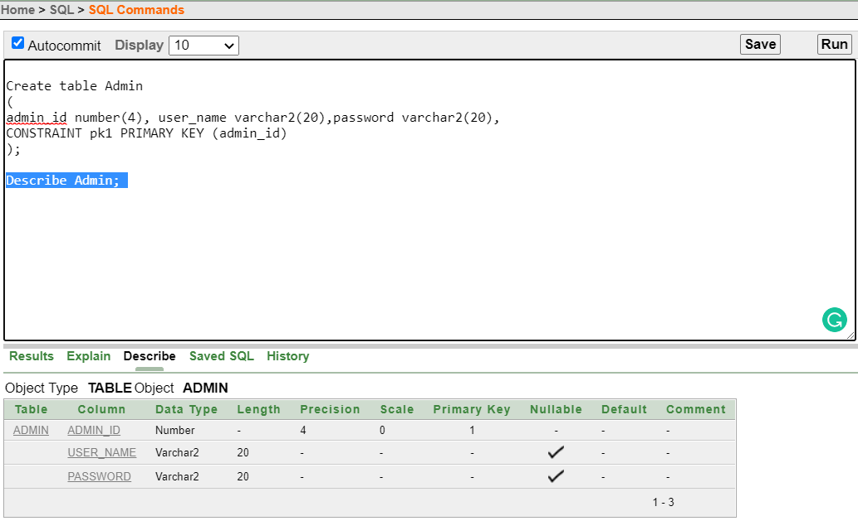

**2. Importer**

Create table Importer(

Importer_id number(4), i_Name varchar2(10),i_Address varchar2(20),i_PhoneNumber number(11),i_Email varchar2(20),admin_id number(4),

CONSTRAINT pk2 PRIMARY KEY (Importer_id),

CONSTRAINT fK1 FOREIGN KEY (admin_id) REFERENCES Admin (admin_id));

Describe Importer;

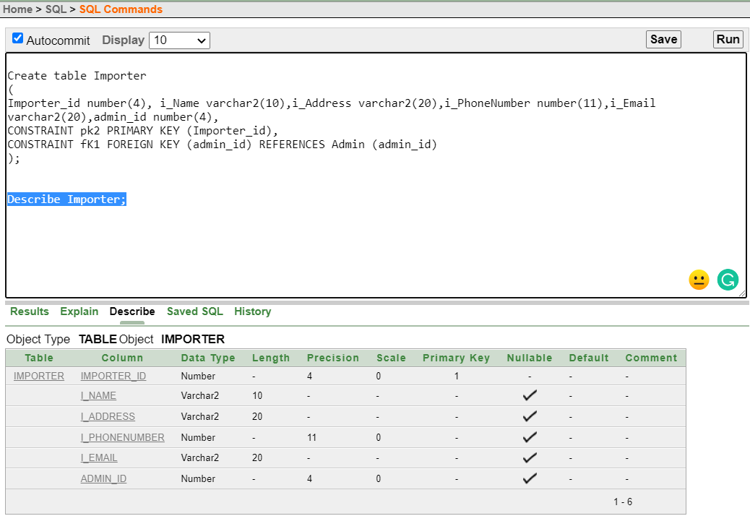

**3. Employee**

Create table Employee(

Employee_id number(4), Employee_Name varchar2(10),e_Address varchar2(20),

e_PhoneNumber number(11),e_Email varchar2(20),admin_id number(4),

CONSTRAINT pk3 PRIMARY KEY (Employee_id),

CONSTRAINT fK2 FOREIGN KEY (admin_id) REFERENCES Admin (admin_id));

Describe Employee;

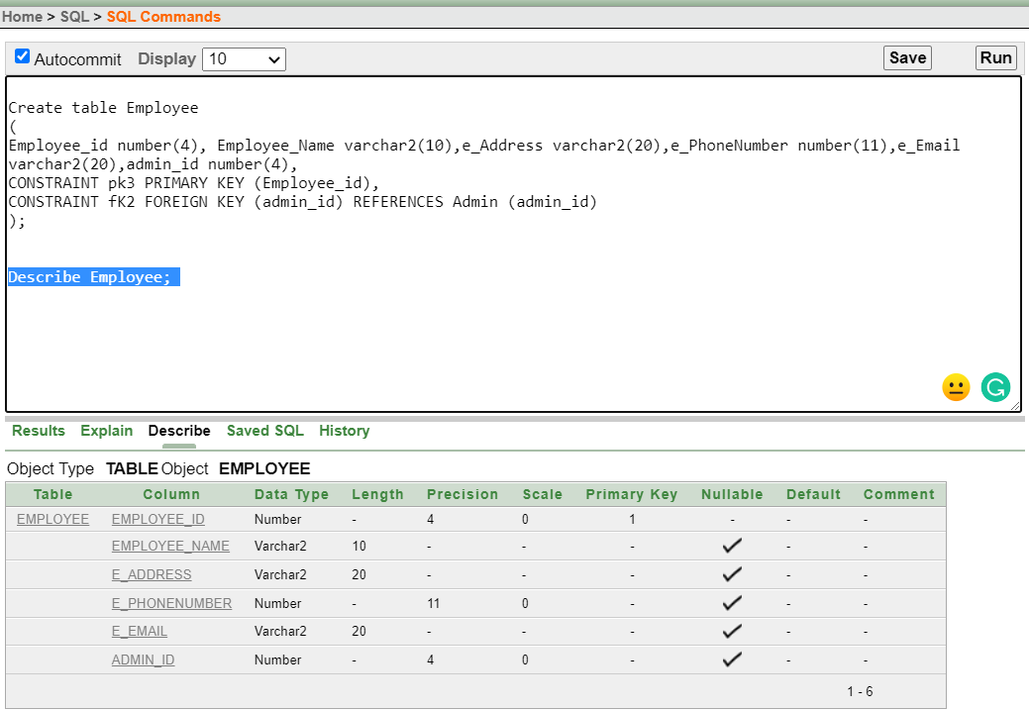

**4. Customer**

Create table Customer(

Customer_id number (4), c_Name varchar2 (10), c_Address varchar2 (20), c_PhoneNumber number (11),c_Email varchar2(20), admin_id number (4), CONSTRAINT pk4 PRIMARY KEY (Customer_id),

CONSTRAINT FK3 FOREIGN KEY (admin_id) REFERENCES Admin (admin_id));

Describe Customer;

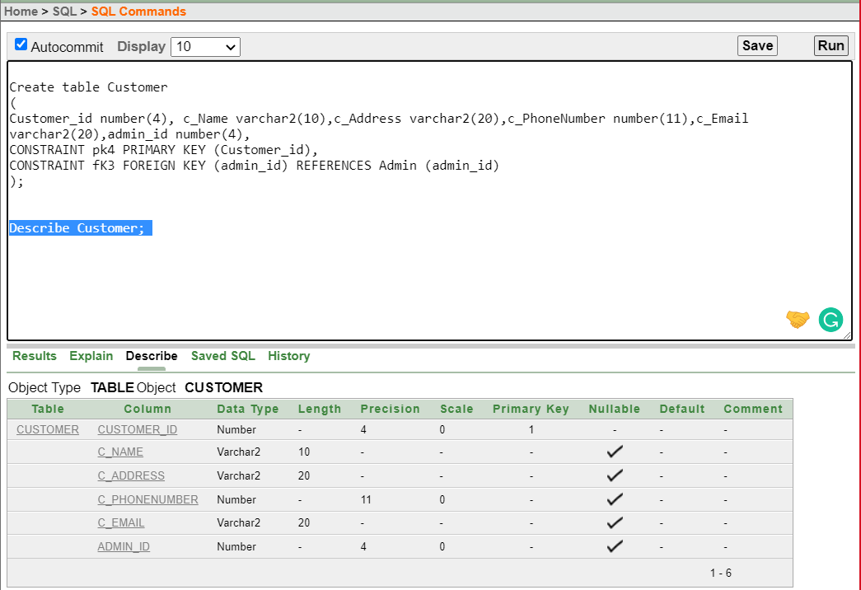

**5. Transaction**

Create table Transaction(

T_id number(4), Sales_Type varchar2(10),Item_name varchar2(20),Quantity number(10),Time_Date Date,Customer_id number(4),

CONSTRAINT pk5 PRIMARY KEY (T_id),

CONSTRAINT fK4 FOREIGN KEY (Customer_id) REFERENCES Customer(Customer_id)

);

Describe Transaction;

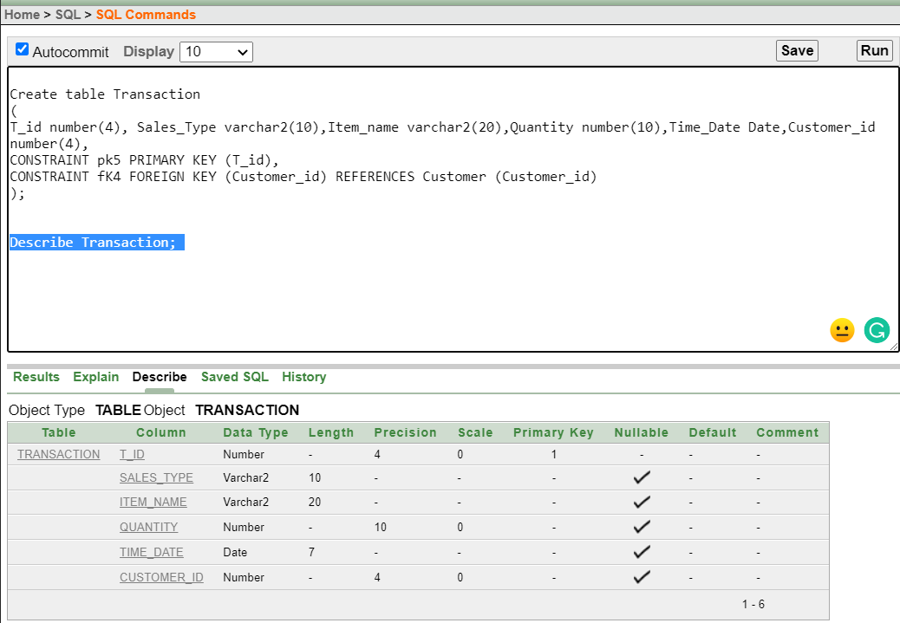

**6. Item**

Create table Item(

Id number(4),Item_name varchar2(20),Category_id number(4),Price number(10),Brand varchar2(20),Quantity number(7),"Size" number(5),Customer_id number(4),

CONSTRAINT pk6 PRIMARY KEY (Id),

CONSTRAINT fK5 FOREIGN KEY (Customer_id) REFERENCES Customer (Customer_id));

Describe Item;

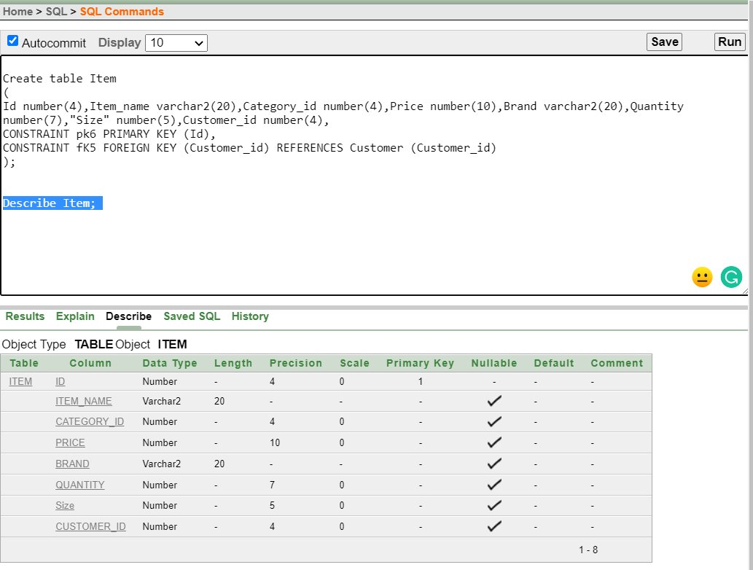

**7. Category**

Create table Category

(Category_id number (4), category_name varchar2(20), CONSTRAINT pk7 PRIMARY KEY (Category_id) );

Describe Category;

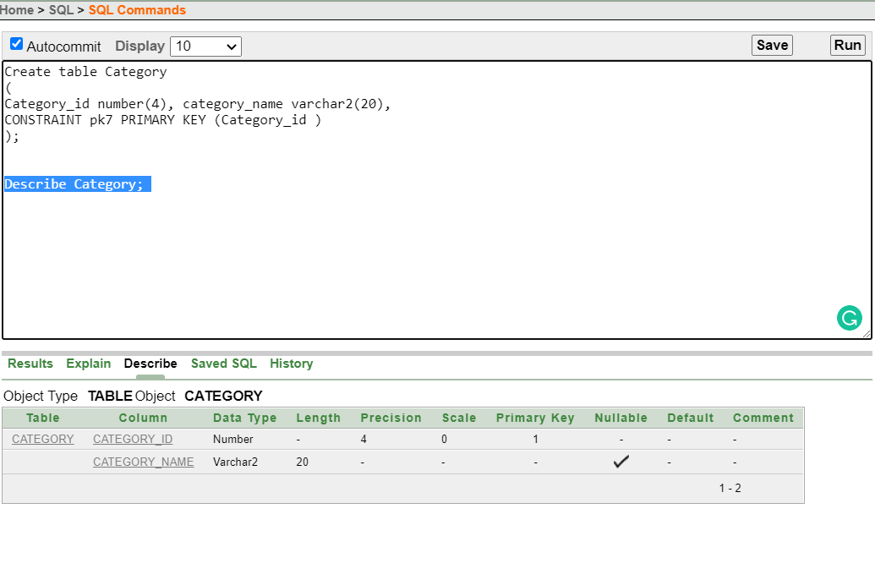

**8. Item_Cate**

Create table Item_Cate

(

Id number(4), Category_id number(4),

CONSTRAINT pk8 PRIMARY KEY (Id,Category_id )

);

Describe Item_Cate;

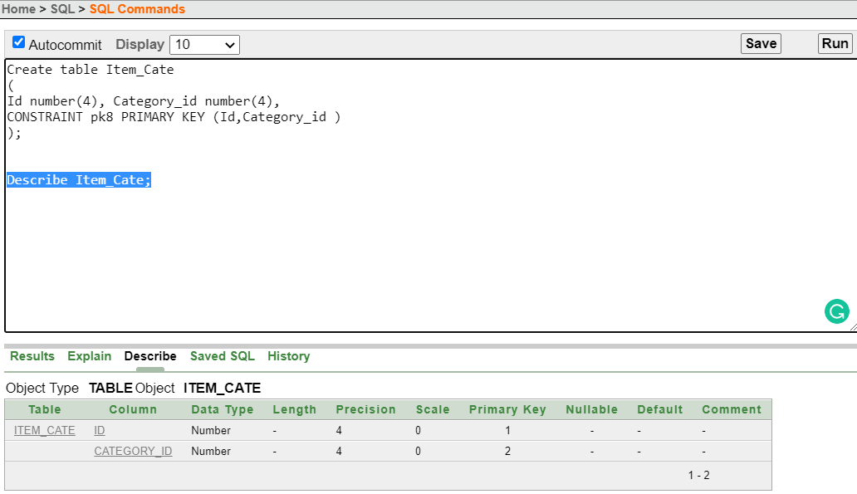

**9. emp_cust**

Create table emp_cust

(

Employee_id number(4), Customer_id number(4),

CONSTRAINT pk9 PRIMARY KEY (Employee_id,Customer_id)

);

Describe emp_cust;

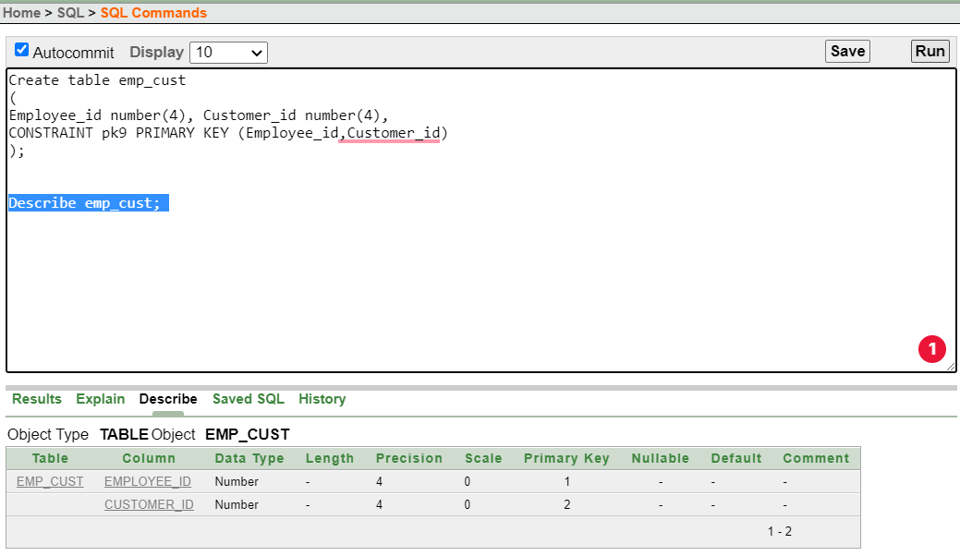

**-Include the queries required to create sequence**

1.CREATE SEQUENCE Admin_adminid

INCREMENT BY 1

START WITH 111;

2.CREATE SEQUENCE Importer_Importerid

INCREMENT BY 1

START WITH 222;

3.CREATE SEQUENCE Employee_empid

INCREMENT BY 1

START WITH 2234;

4.CREATE SEQUENCE Customer_Customerid

INCREMENT BY 1

START WITH 333;

5.CREATE SEQUENCE Transaction_Tid

INCREMENT BY 1

START WITH 444;

6.CREATE SEQUENCE Item_Id

INCREMENT BY 1

START WITH 6666;

7.CREATE SEQUENCE Category_Categoryid

INCREMENT BY 1

START WITH 777;

8. CREATE SEQUENCE Item_CateId

INCREMENT BY 1

START WITH 6686;

9.CREATE SEQUENCE emp_custid

INCREMENT BY 1

START WITH 2234;

# Data Insertion:

**1.Admin:**

INSERT INTO Admin (admin_id, user_name, password) VALUES (Admin_adminid.NEXTVAL, 'a', 'abcd1234');

INSERT INTO Admin (admin_id, user_name, password) VALUES (Admin_adminid.NEXTVAL, 'b','adcd1254');

INSERT INTO Admin (admin_id, user_name, password) VALUES (Admin_adminid.NEXTVAL, 'c', 'xbzd12649');

INSERT INTO Admin (admin_id, user_name, password) VALUES (Admin_adminid.NEXTVAL, 'd', 'abc412rh4');

INSERT INTO Admin (admin_id, user_name, password) VALUES (Admin_adminid.NEXTVAL, 'e', 'aegcdlyj34');

Select * from Admin;

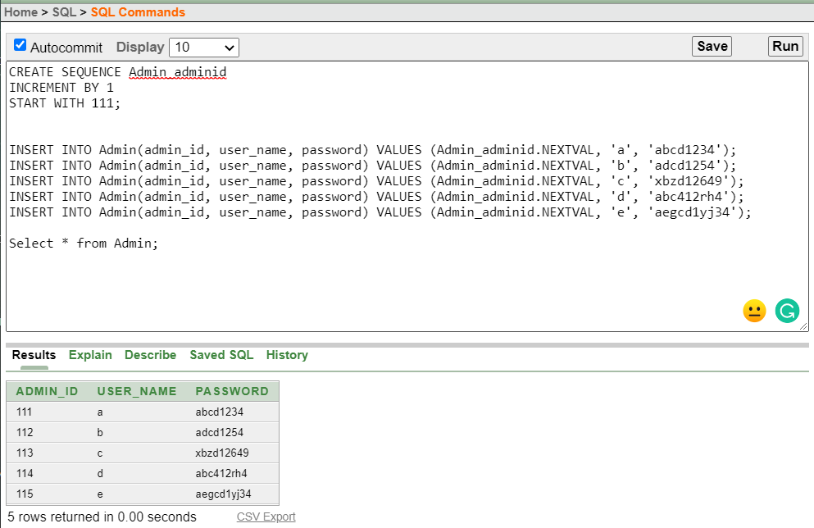

**2.Importer:**

INSERT INTO Importer(Importer_id, i_name, i_address,i_PhoneNumber,i_Email,admin_id) VALUES (Importer_Importerid.NEXTVAL, 'x', 'Beijing-China','+8616521689','x1@gmail.com','111');

INSERT INTO Importer(Importer_id, i_name, i_address,i_PhoneNumber,i_Email,admin_id) VALUES (Importer_Importerid.NEXTVAL, 'x2', 'Chittagong-BD','01712345678','x2@gmail.com','112');

INSERT INTO Importer(Importer_id, i_name, i_address,i_PhoneNumber,i_Email,admin_id) VALUES (Importer_Importerid.NEXTVAL, 'x3', 'Tokyo-Japan','+8114541689','x3@gmail.com','113');

INSERT INTO Importer(Importer_id, i_name, i_address,i_PhoneNumber,i_Email,admin_id) VALUES (Importer_Importerid.NEXTVAL, 'x4', 'Rajshahi-Bangladesh','01812345679','x4@gmail.com','114');

INSERT INTO Importer(Importer_id, i_name, i_address,i_PhoneNumber,i_Email,admin_id) VALUES (Importer_Importerid.NEXTVAL, 'x5', 'Macau-China','+8608521657','x5@gmail.com','115');

Select * from Importer;

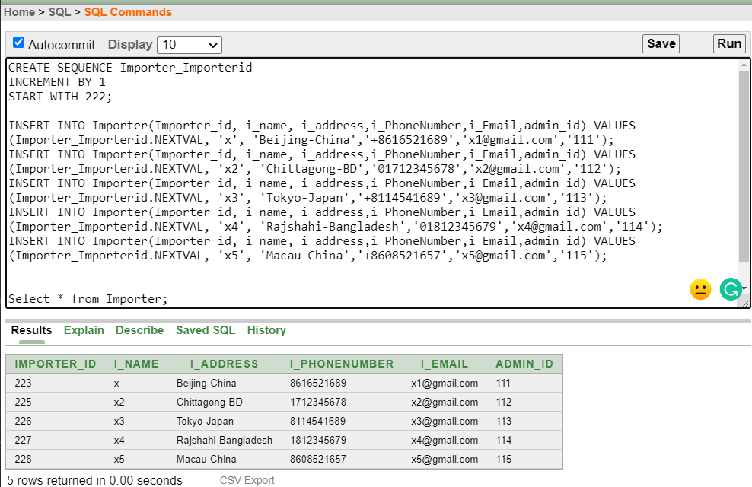

**3.Employee:**

INSERT INTO

Employee(Employee_id,Employee_Name,e_Address,e_PhoneNumber,e_Email,admin_id) VALUES

(Employee_empid.NEXTVAL, 'd1' ,'Dhaka-BD','01988256435','d1@gmail.com','111')

INSERT INTO Employee(Employee_id,Employee_Name,e_Address,e_PhoneNumber,e_Email,admin_id) VALUES

(Employee_empid.NEXTVAL, 'd2','Kushtia-BD','01988253576','d2@gmail.com','112')

INSERT INTO Employee(Employee_id,Employee_Name,e_Address,e_PhoneNumber,e_Email,admin_id) VALUES

(Employee_empid.NEXTVAL, 'd3' ,'Pabna-BD','01988256777','d3@gmail.com','113')

INSERT INTO Employee(Employee_id,Employee_Name,e_Address,e_PhoneNumber,e_Email,admin_id) VALUES

(Employee_empid.NEXTVAL, 'd4' ,'Cumilla-BD','01988256755','d4@gmail.com','114')

INSERT INTO Employee(Employee_id,Employee_Name,e_Address,e_PhoneNumber,e_Email,admin_id) VALUES

(Employee_empid.NEXTVAL, 'd5' ,'Chittagong-BD','01988356743','d5@gmail.com','115')

Select * from Employee;

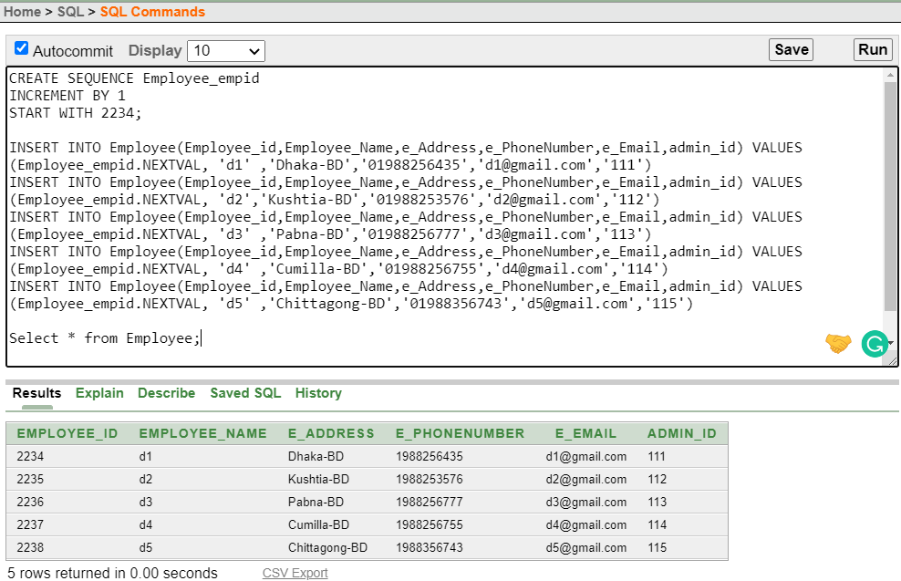

**4.Customer:**

INSERT INTO Customer(Customer_id, c_name, c_address,c_PhoneNumber,c_Email,admin_id) VALUES (Customer_Customerid.NEXTVAL, 'c1', 'Dhaka-Bd','01758792437','c1@gmail.com','111');

INSERT INTO Customer(Customer_id, c_name, c_address,c_PhoneNumber,c_Email,admin_id) VALUES (Customer_Customerid.NEXTVAL, 'c2', 'Narayanganj-Bd','01858729223','c2@gmail.com','112');

INSERT INTO Customer(Customer_id, c_name, c_address,c_PhoneNumber,c_Email,admin_id) VALUES (Customer_Customerid.NEXTVAL, 'c3', 'Cumilla-Bd','01958792444','c3@gmail.com','113');

INSERT INTO Customer(Customer_id, c_name, c_address,c_PhoneNumber,c_Email,admin_id) VALUES (Customer_Customerid.NEXTVAL, 'c4', 'Dhaka-Bd','01358792476','c4@gmail.com','114');

INSERT INTO Customer(Customer_id, c_name, c_address,c_PhoneNumber,c_Email,admin_id) VALUES (Customer_Customerid.NEXTVAL, 'c5', 'Chittagong-Bd','01558792489','c5@gmail.com','115');

Select * from Customer;

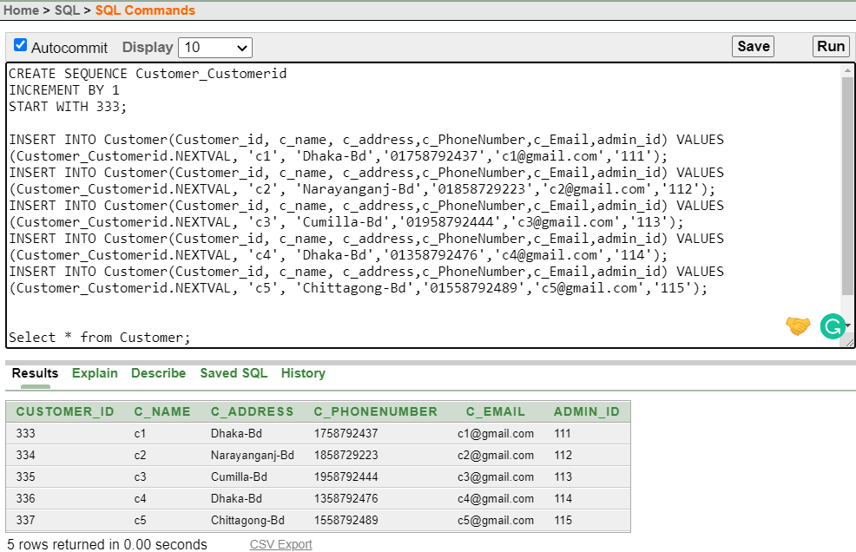

**5.Transaction:**

INSERT INTO Transaction(T_id, Sales_Type, Item_name,Quantity,Time_Date,Customer_id) VALUES (Transaction_Tid.NEXTVAL, 'Online', 'T_Shirt','3','19-oct-2022','333');

INSERT INTO Transaction(T_id, Sales_Type, Item_name,Quantity,Time_Date,Customer_id) VALUES (Transaction_Tid.NEXTVAL, 'Inside ', 'Coca-Cola', '4','20-oct-2022', '334') ;

INSERT INTO Transaction(T_id, Sales_Type, Item_name,Quantity,Time_Date,Customer_id) VALUES (Transaction_Tid.NEXTVAL, 'Inside ', 'Roast Chicken','2','21-oct-2022','335');

INSERT INTO Transaction(T_id, Sales_Type, Item_name,Quantity,Time_Date,Customer_id) VALUES (Transaction_Tid.NEXTVAL, 'Online', 'Water Melon','3','22-oct-2022','336');

INSERT INTO Transaction(T_id, Sales_Type, Item_name,Quantity,Time_Date,Customer_id) VALUES (Transaction_Tid.NEXTVAL, 'Inside ', 'Pen Set','8', '23-oct-2022','337');

Select * from Transaction;

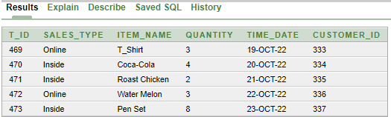

**6.Item:**

INSERT INTO Item(Id ,Item_name,Category_id,Price,Brand,Quantity,"Size",Customer_id ) VALUES(Item_Id.NEXTVAL, 'Pepsi' ,'777','20','Pepsico','1','1','333');

INSERT INTO Item(Id ,Item_name,Category_id,Price,Brand,Quantity,"Size",Customer_id ) VALUES(Item_Id.NEXTVAL,'Apple','778','195','None','1','1','334');

INSERT INTO Item(Id ,Item_name,Category_id,Price,Brand,Quantity,"Size",Customer_id ) VALUES(Item_Id.NEXTVAL, 'Egg' ,'779','9','Kazi','1','1','335');

INSERT INTO Item(Id ,Item_name,Category_id,Price,Brand,Quantity,"Size",Customer_id ) VALUES(Item_Id.NEXTVAL, 'Rice' ,'780','75','Pran','1','1','336');

INSERT INTO Item(Id ,Item_name,Category_id,Price,Brand,Quantity,"Size",Customer_id ) VALUES(Item_Id.NEXTVAL, 'Orange' ,'781','238','NONE','1','1','337');

Select * from Item;

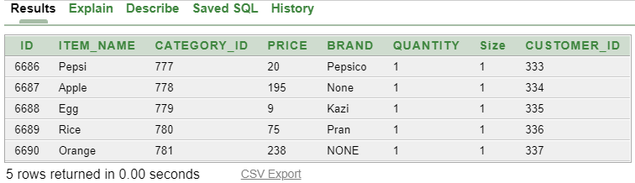

**7.Category:**

INSERT INTO Category(Category_id, Category_name) VALUES (Category_Categoryid.NEXTVAL, 'cate1');

INSERT INTO Category(Category_id, Category_name) VALUES (Category_Categoryid.NEXTVAL, 'cate2');

INSERT INTO Category(Category_id, Category_name) VALUES (Category_Categoryid.NEXTVAL, 'cate3');

INSERT INTO Category(Category_id, Category_name) VALUES (Category_Categoryid.NEXTVAL, 'cate4');

INSERT INTO Category(Category_id, Category_name) VALUES (Category_Categoryid.NEXTVAL, 'cate5');

Select * from Category;

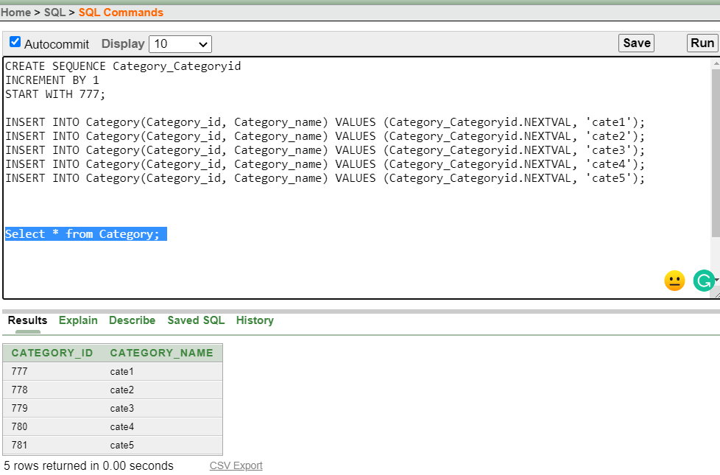

**8.Item_Cate:**

INSERT INTO Item_Cate(Id,Category_id) VALUES(Item_CateId.NEXTVAL,'777');

INSERT INTO Item_Cate(Id,Category_id) VALUES(Item_CateId.NEXTVAL,'778');

INSERT INTO Item_Cate(Id,Category_id) VALUES(Item_CateId.NEXTVAL,'779');

INSERT INTO Item_Cate(Id,Category_id) VALUES(Item_CateId.NEXTVAL,'780');

INSERT INTO Item_Cate(Id,Category_id) VALUES(Item_CateId.NEXTVAL,'781');

Select* From Item_Cate;

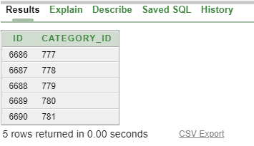

**9.emp_cust:**

INSERT INTO emp_cust(Employee_Id,Customer_id) VALUES(emp_custid.NEXTVAL,'333')

INSERT INTO emp_cust(Employee_Id,Customer_id) VALUES(emp_custid.NEXTVAL,'334')

INSERT INTO emp_cust(Employee_Id,Customer_id) VALUES(emp_custid.NEXTVAL,'335')

INSERT INTO emp_cust(Employee_Id,Customer_id) VALUES(emp_custid.NEXTVAL,'336')

INSERT INTO emp_cust(Employee_Id,Customer_id) VALUES(emp_custid.NEXTVAL,'337')

Select * from emp_cust;

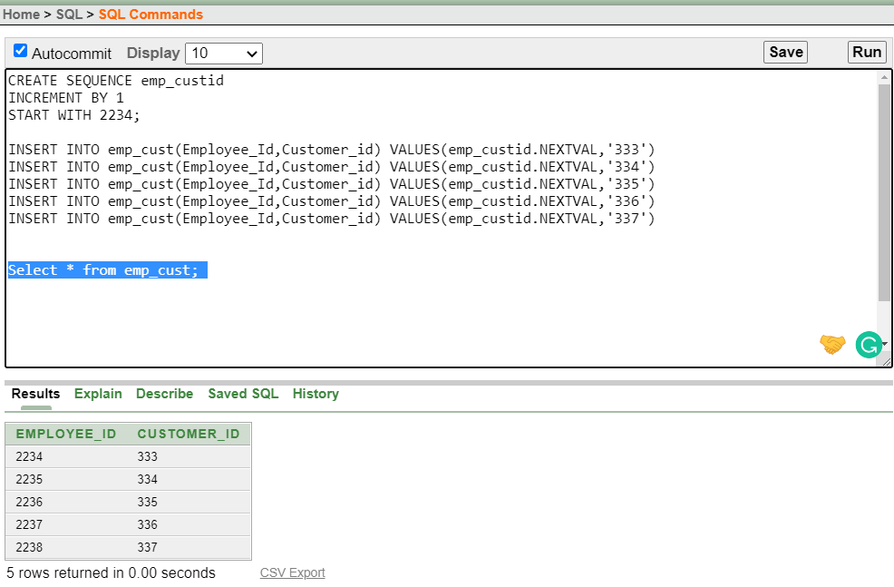

# Query Writing:

**-3 single row function**

Q1:Use TO_CHAR function with dates to show item enlist date

Ans: SELECT Item_name,

TO_CHAR(Time_Date, 'fmDD Month YYYY') Time_Date

FROM Transaction;

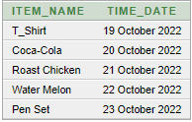

Q2:Use CONCAT function to concatenate two string values.

Ans: SELECT CONCAT (Item_name, Brand)

FROM Item

WHERE rownum < 6;

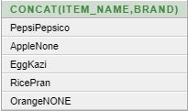

Q3: Calculate how many days have passed since one product purchase using the date arithmetic function.

Ans: SELECT T_id, (sysdate - Time_Date) Passed_days

FROM Transaction

WHERE rownum < 5;

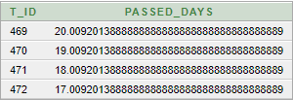

**-3 group function**Q1:Display the Item_name which is more costly than egg and group by its name

Ans: SELECT Item_name, max(Price)

FROM Item

GROUP BY Item_name

HAVING max(Price)>9;

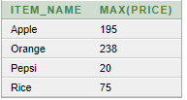

Q2:Display the Item_name which is more costlier than egg and group by its name

Ans: SELECT Item_name, min(Price)

FROM Item

GROUP BY Item_name

HAVING min(Price)<238;

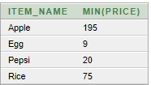

Q3:Display the oldest and latest date of transaction

Ans: SELECT MIN (Time_Date) oldest, MAX (Time_Date) latest

FROM Transaction;



**-3 subquery**

Q1:Display the Item_name which is more less costlier than orange.

Ans:

Select * from Item;

select Item_name from Item where Price> (select Price from Item where Item_name ='Apple')

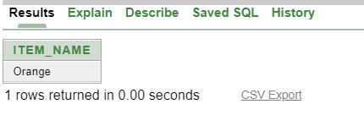

Q2: Display the c_name who use email address "c5@gmail.com"

Ans:

Select * from Customer;

select c_name from Customer where c_Email = (select c_Email from Customer where c_Email ='c5@gmail.com');

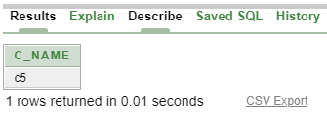

Q3: Display which items are bought earlier than pen set

Ans: SELECT Item_name,T_Id

FROM Transaction

WHERE Time_Date< (SELECT Time_Date

FROM Transaction

WHERE T_id=473);

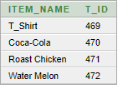

**-3 joining**

Q1: Display the name of the employee who give services to customer id 334.

Ans: SELECT Employee.Employee_Name

from Employee ,emp_cust

where Employee.Employee_id=emp_cust.Employee_id and emp_cust.Customer_id='334';

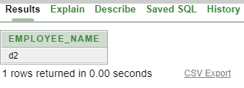

Q2: Display the name of the Item which one belongs to category id "780"

Ans:

SELECT Item.Item_name

from Item,Item_Cate

where Item.Category_id=Item_Cate.Category_id and Item_Cate.Category_id='780';

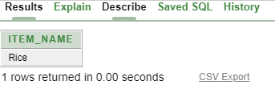

Q3: Display the name of the Item which bought by the particular customer

Ans: SELECT Customer.c_name from Customer,Transaction where Customer.Customer_id=Transaction .Customer_id and Transaction .Customer_id =336;



**-3 View**

**Q1:** Create a view called CategoryView based on the Category_id from the Category table.

**Ans:**

CREATE VIEW CategoryView

AS SELECT Category_id

FROM Category

WHERE Category_name = 'cate5';

Select * from CategoryView;

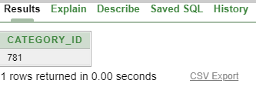

**Q2:** Create a view called ItemView based on the Item_name and Price from the Item table.

**Ans:**

CREATE VIEW ItemView

AS SELECT Item_name,Price

FROM Item

WHERE Id = 6688;

Select * from ItemView;

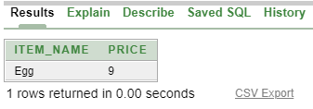

**Q3:** Create a view called ItemInfo that contains item name,price and brand

**Ans:** CREATE VIEW ItemInfo

AS SELECT Item_name , Price,Brand

FROM Item

where Id=6686;

**-3 synonym**

**Q1:** Create a synonym for view called ItemInfo

**Ans:** CREATE SYNONYM ItemI

For ItemInfo;

**Q2:** Create a synonym for view called ItemView

**Ans:** CREATE SYNONYM ItemV

For ItemView;

**Q3:** Create a synonym for view called CategoryView

**Ans:** CREATE SYNONYM CateV

For CategoryView;

# **Conclusion:**

This is a primary scenario of a superstore management system. The main lacking of this application is we cannot add all the sectors of a superstore. In reality the superstore management system is too big and the stored data is huge. But it might be helpful for them who want to build a superstore. Owner can implement the management of a superstore by taking the idea